**PROJECT**

**Chat Application**

**GROUP: 1**

**Nguyễn Lê Tài Đức**

**Lê Bá Thịnh**

**Tô Cao Kim Ngân**

**Trần Minh Nhựt**

1. **Architecture Diagram**

- Independent deployment and scaling: Each feature can be deployed and scaled separately.

- Enhanced fault isolation: Failures in one service don't impact others.

- Technology diversity: Various languages for each component.

- Streamlined development and maintenance: Teams can work on individual services independently.

- Faster innovation: Enables quicker updates and new feature implementations.

- Higher availability and reliability: Ensures a more resilient and stable application.

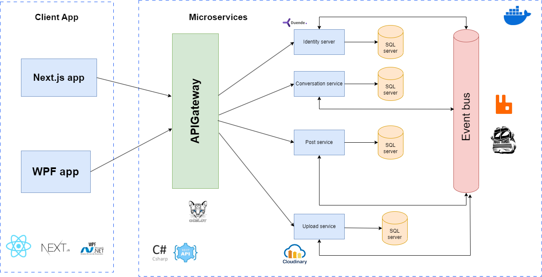

1. **Subsystem Diagram**
   1. **High Level**

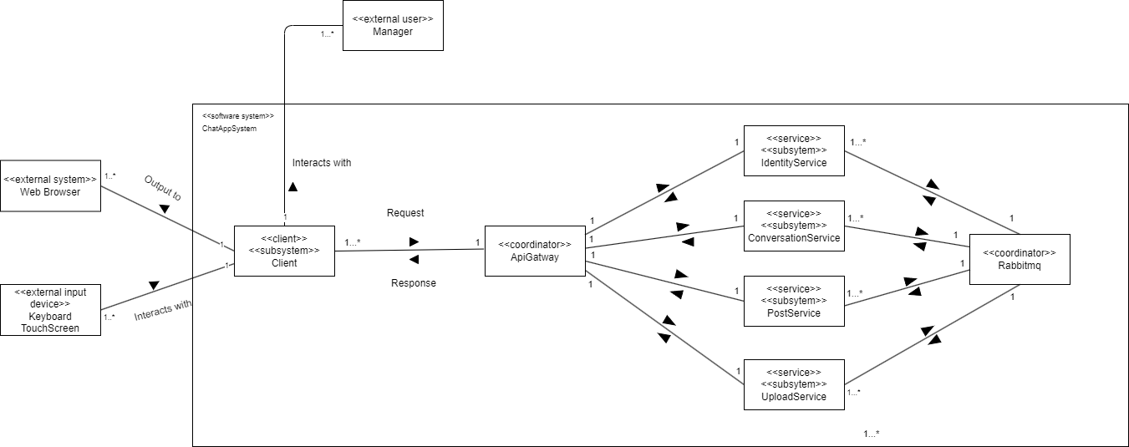

* 1. **Identity**

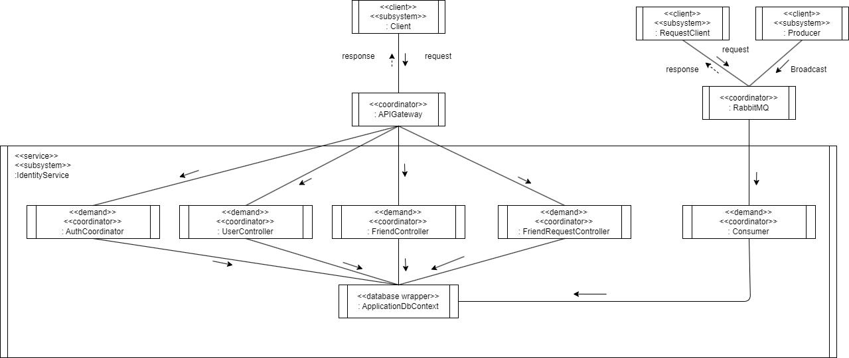

* 1. **Conversation**

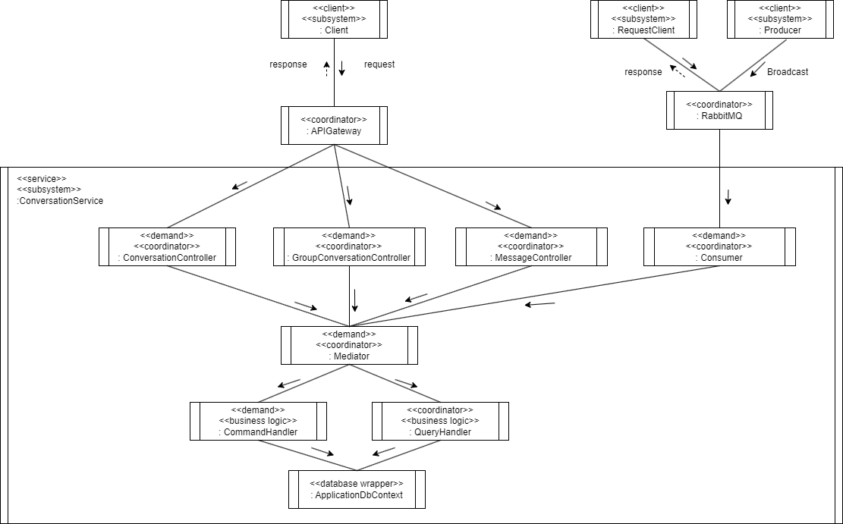

* 1. **Upload**

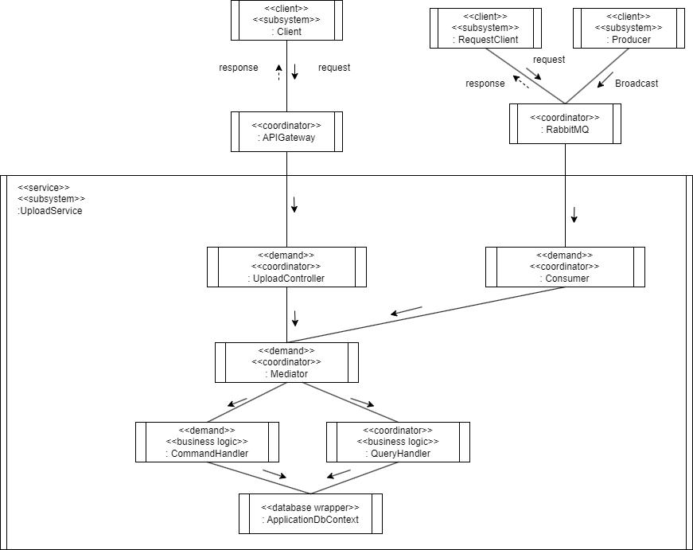

* 1. **Post**

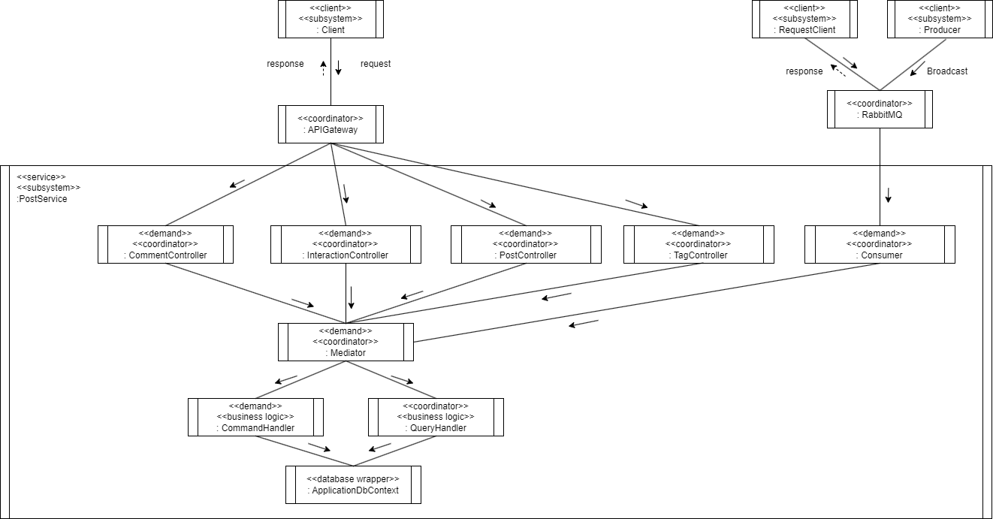

1. **Class Diagram**
   1. **Identity**
      1. **Accept Friend Request**

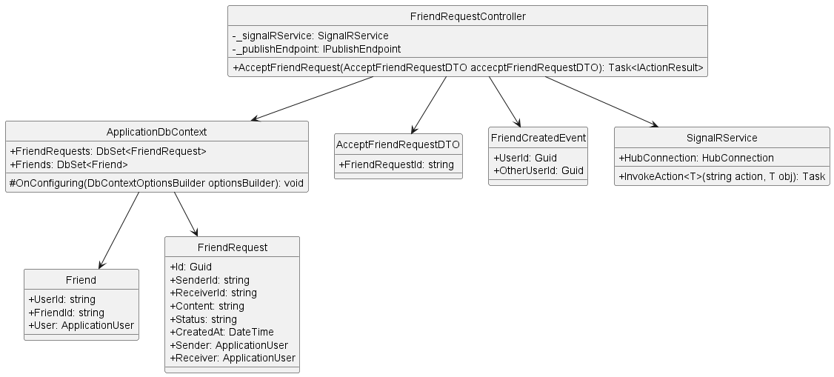

* + 1. **Block User**

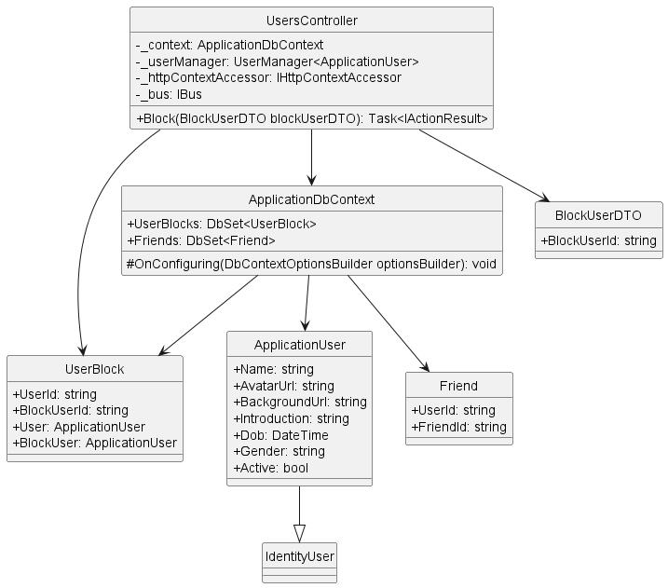

* + 1. **Delete Friend**

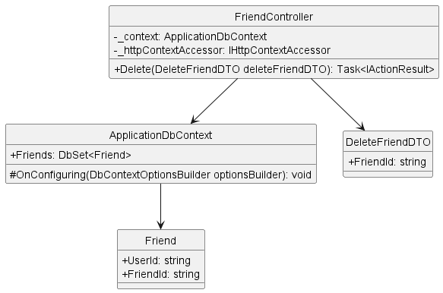

* + 1. **Delete Friend Request**

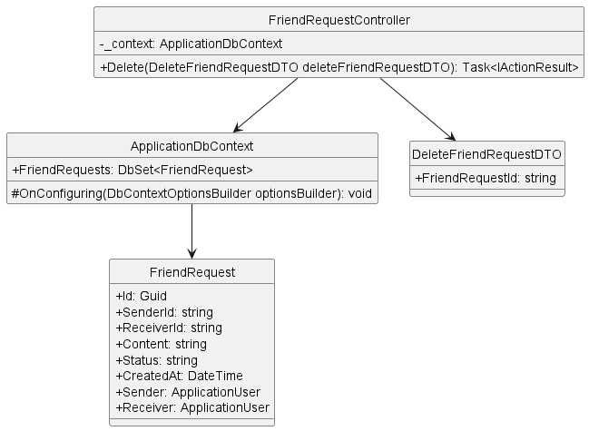

* + 1. **Get Friend List By User Id**

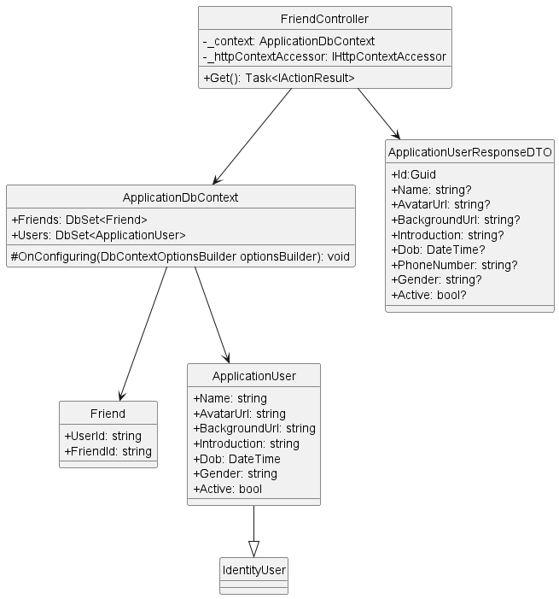

* + 1. **Get Friend Request List**

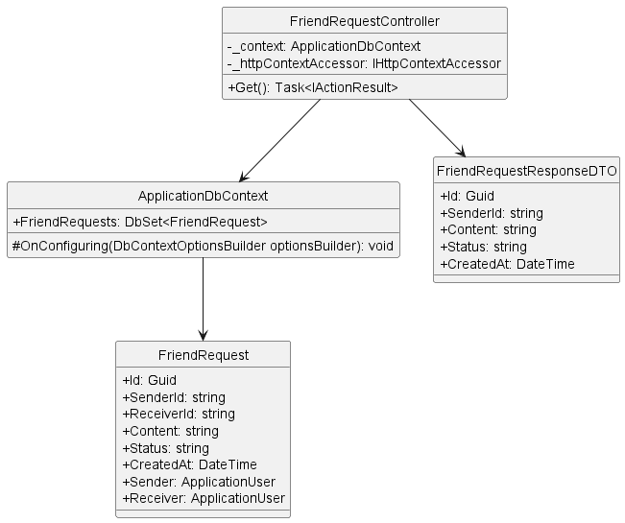

* + 1. **Get User By Id**

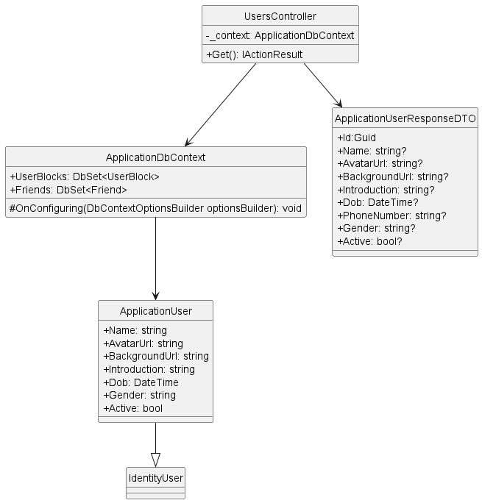

* + 1. **Login**

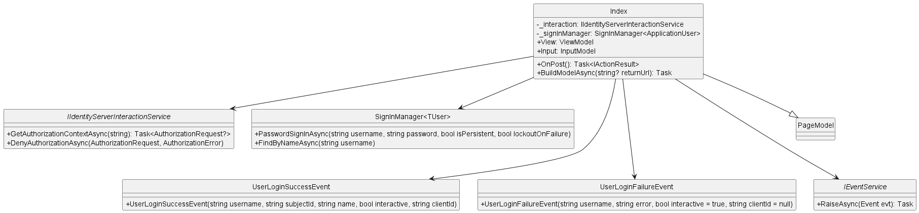

* + 1. **Register**

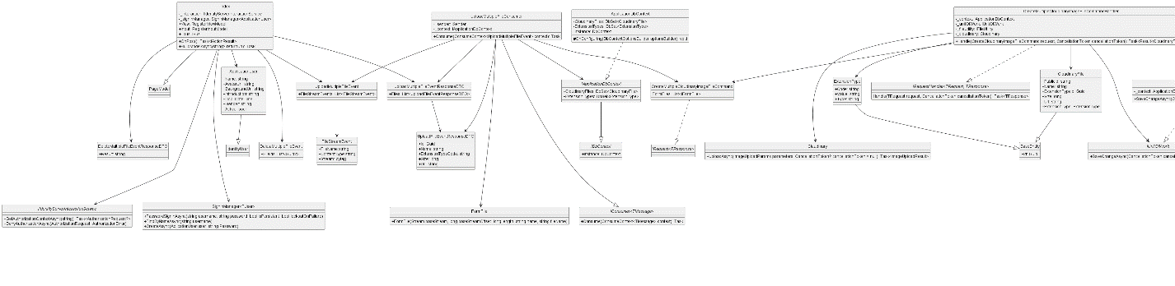

* + 1. **Search User**

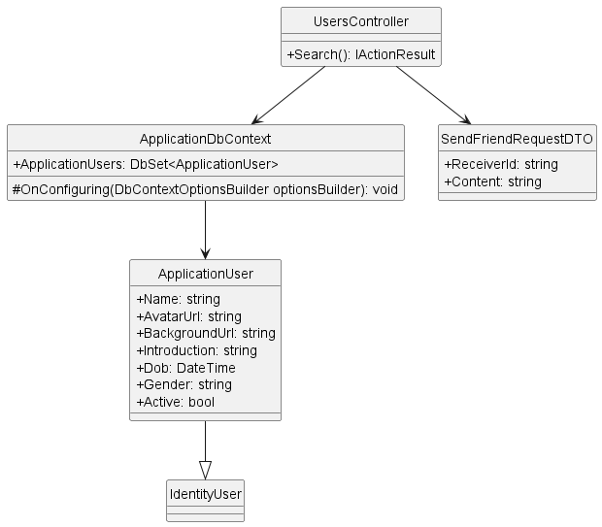

* + 1. **Send Friend Request**

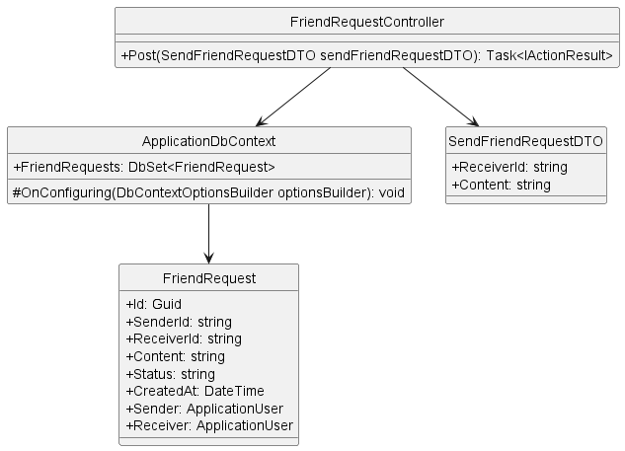

* + 1. **Unblock User**

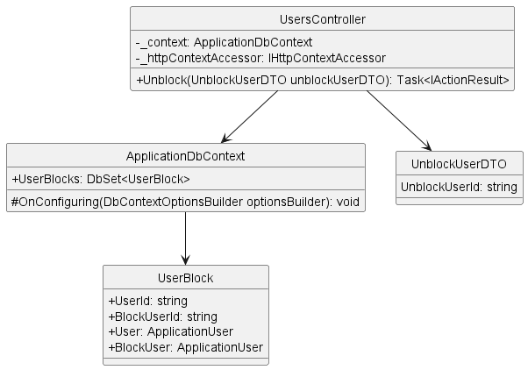

* + 1. **Update User**

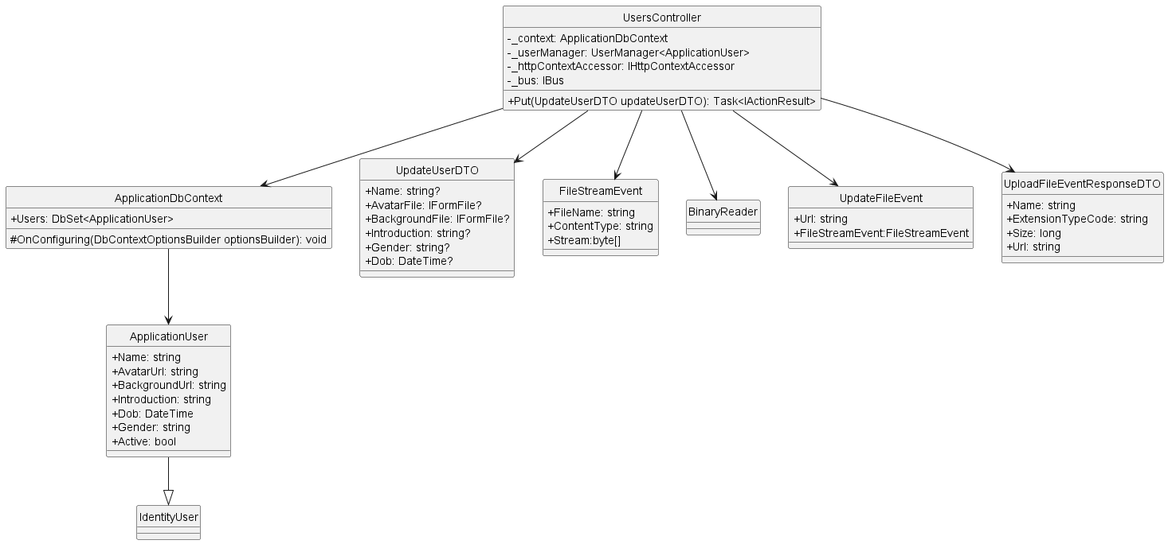

* 1. **Conversation**
     1. **Create Group Conversation**

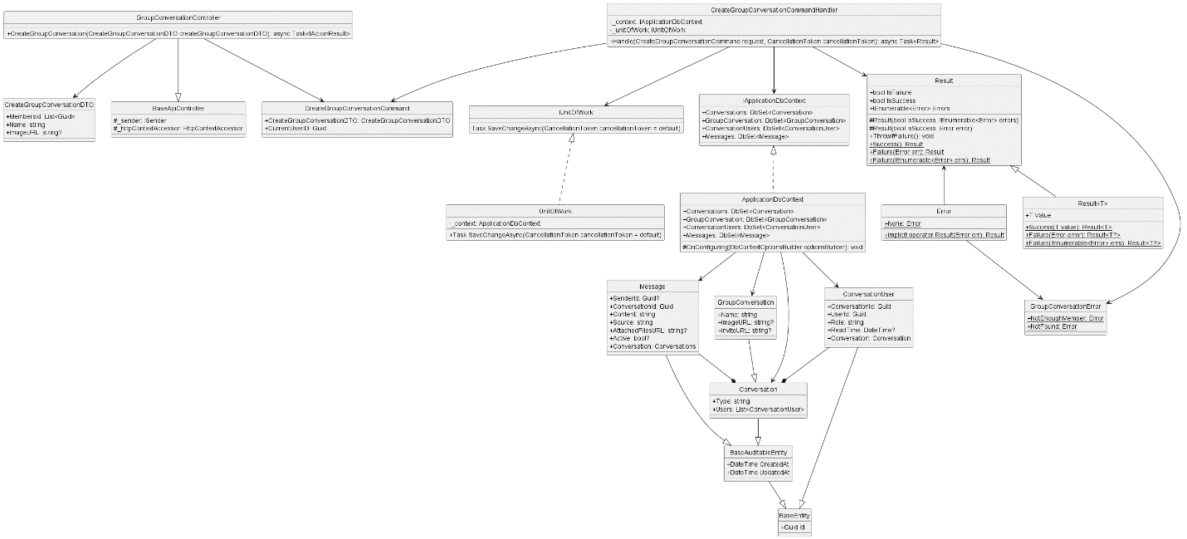

* + 1. **Delete Conversation**

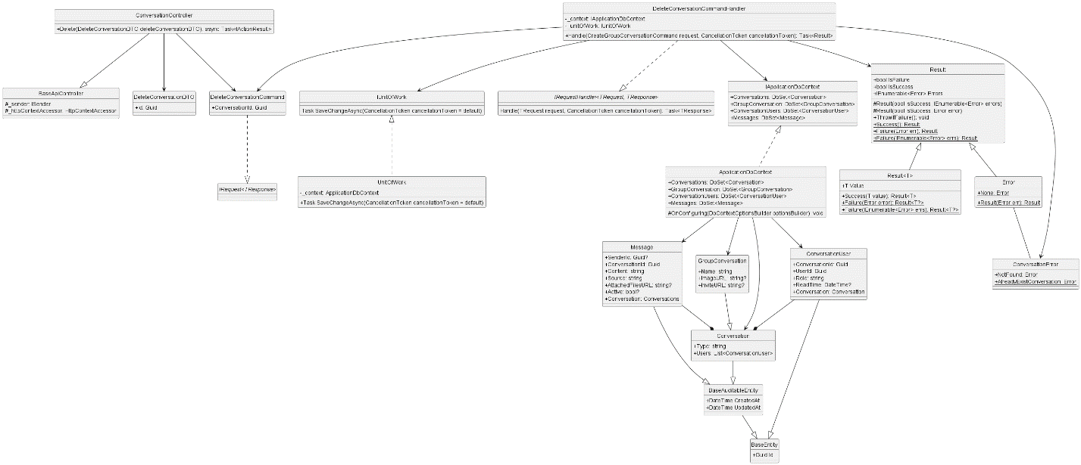

* + 1. **Get All**

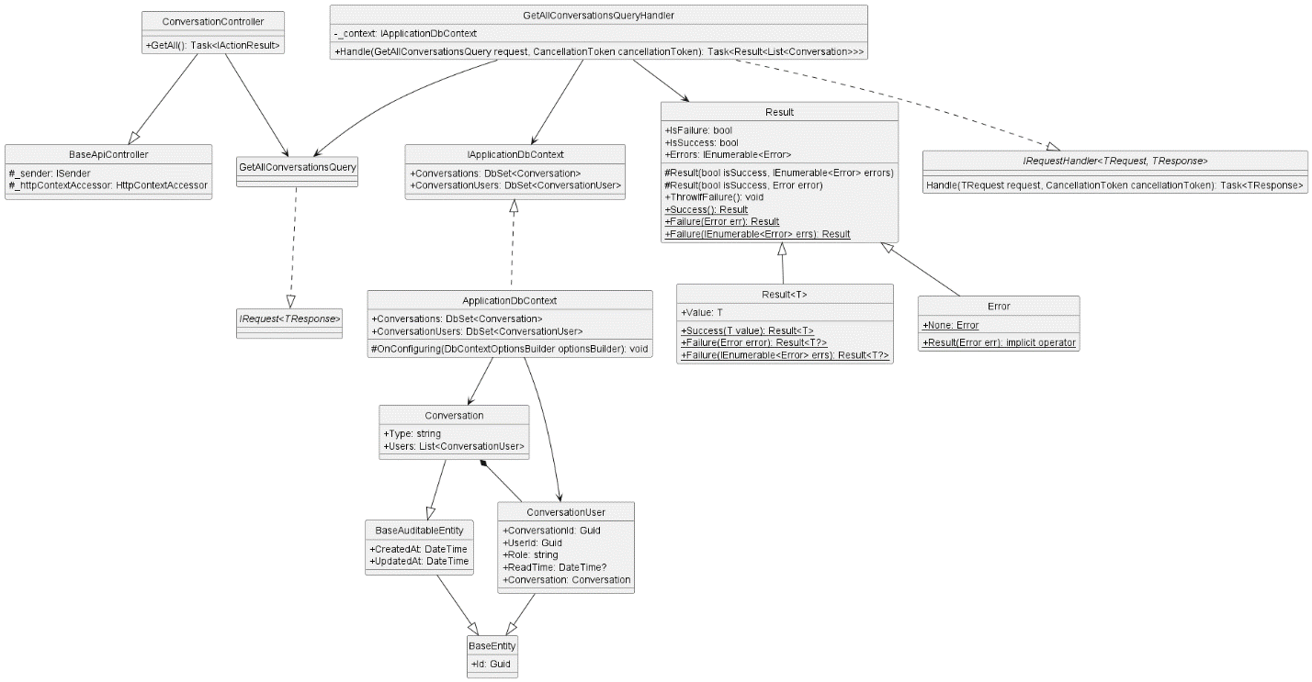

* + 1. **Get By Id**

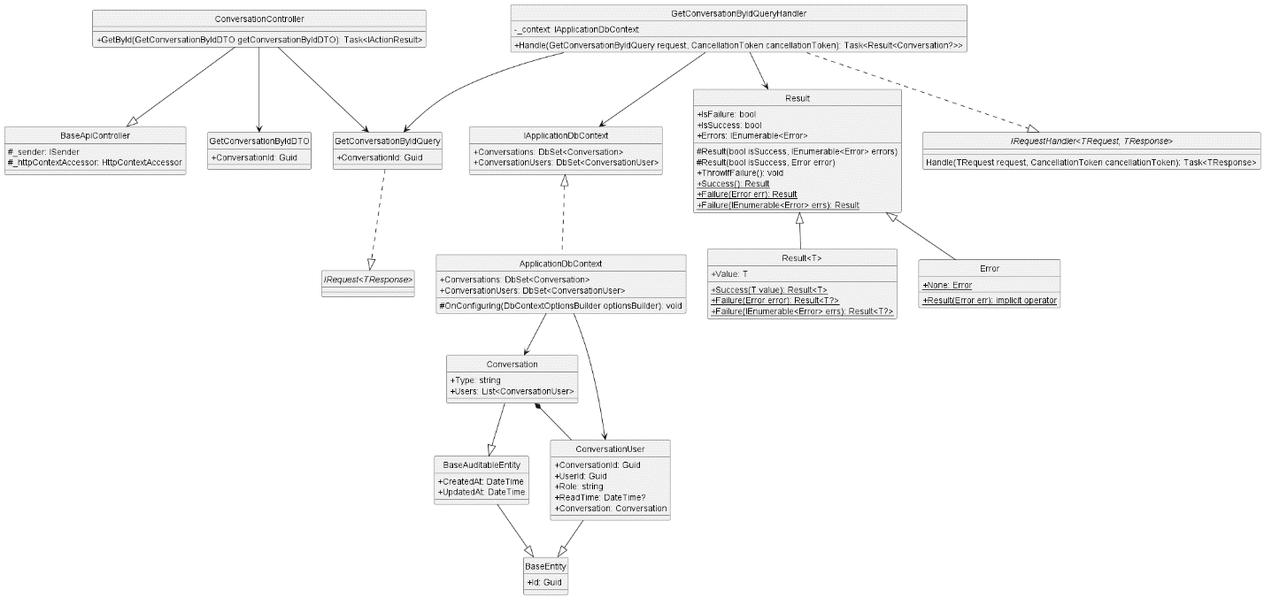

* + 1. **Get Conversation**

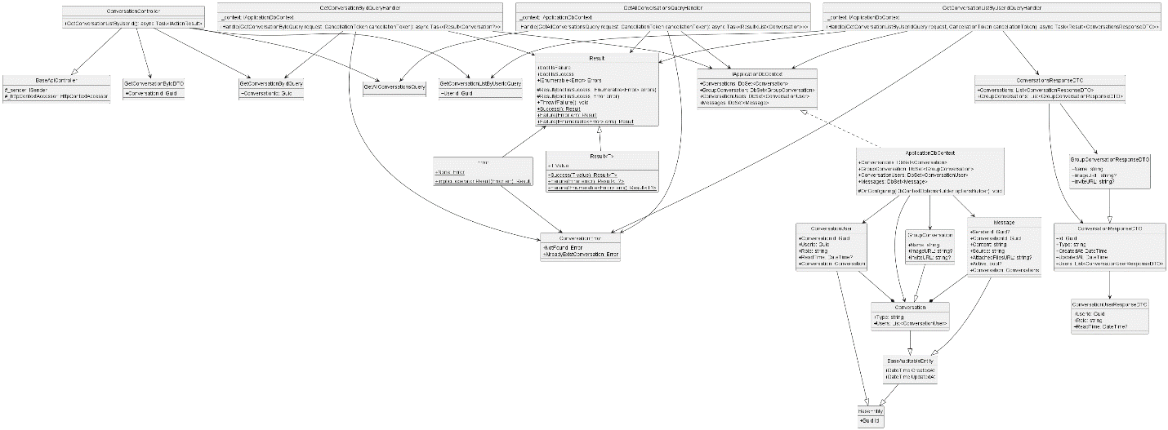

* + 1. **Get Conversation List By User Id**

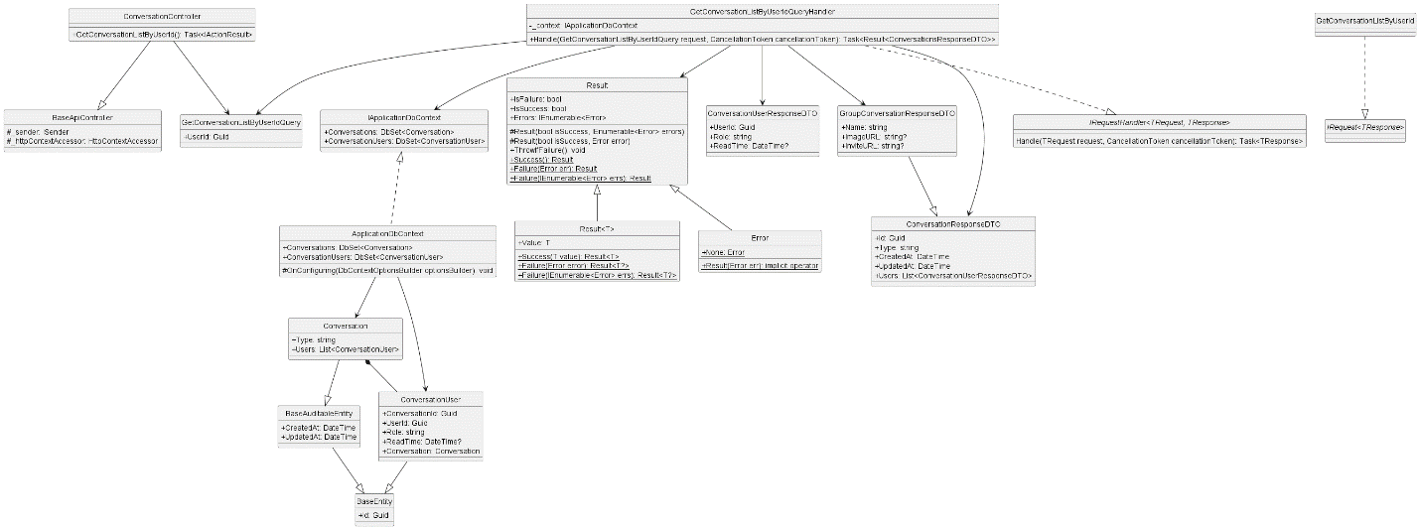

* + 1. **Get Member List By Conversation Id**

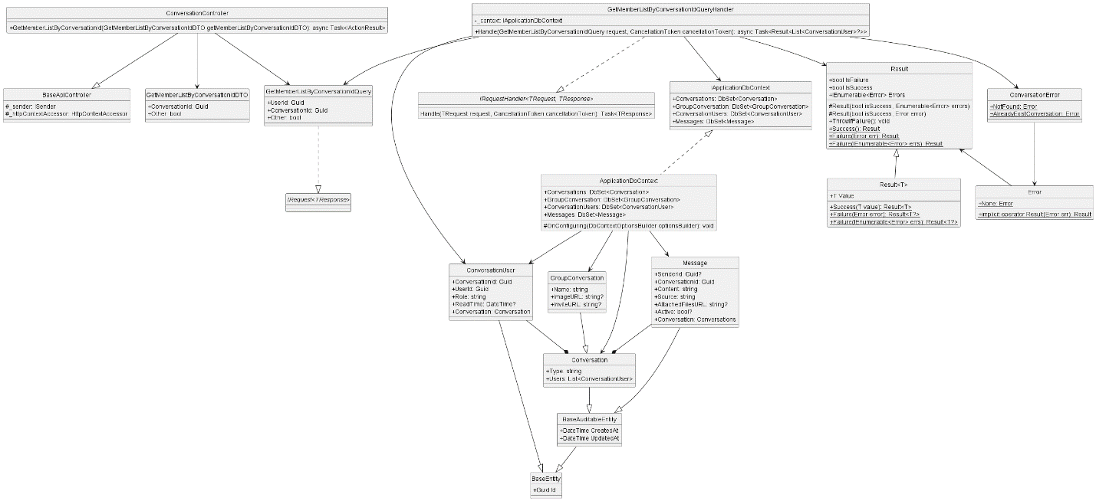

* + 1. **Group Add User**

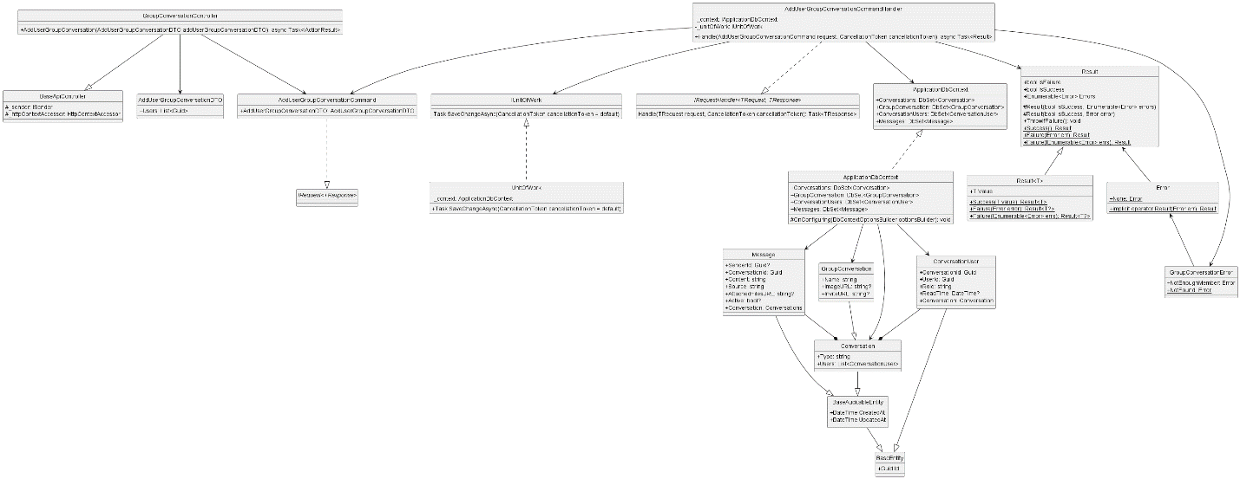

* + 1. **Group Block User**

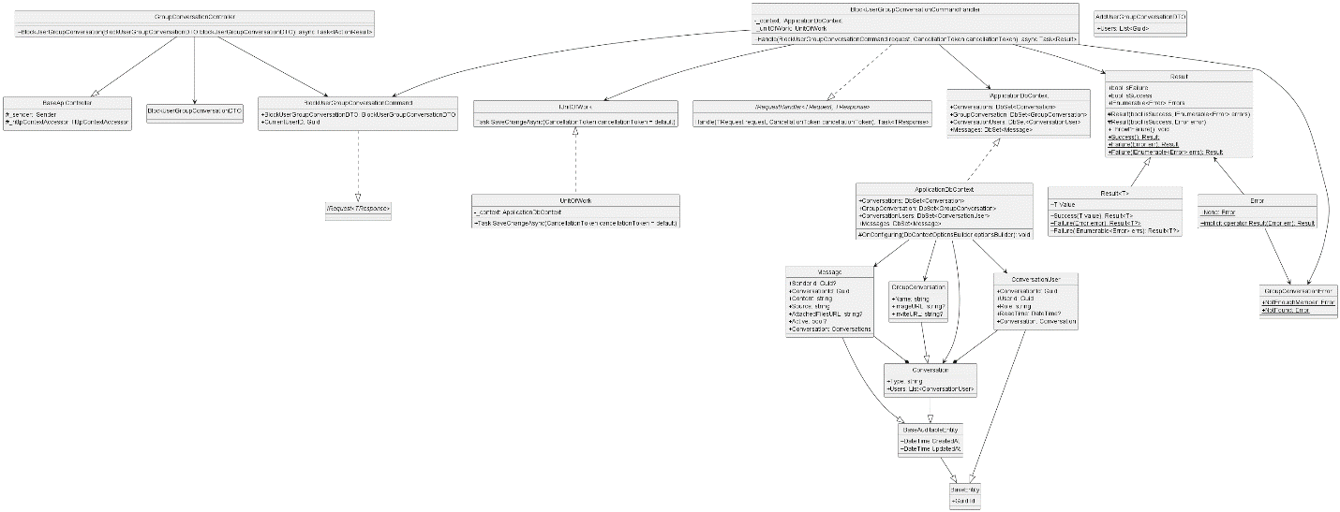

* + 1. **Group Disband**

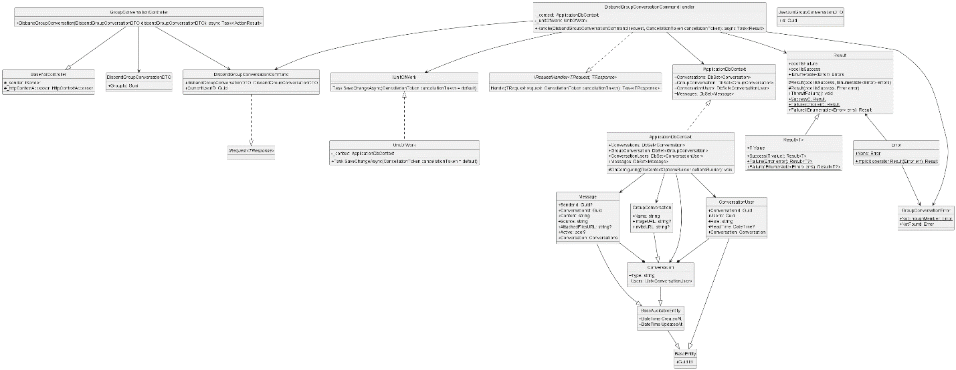

* + 1. **Send Client Message**

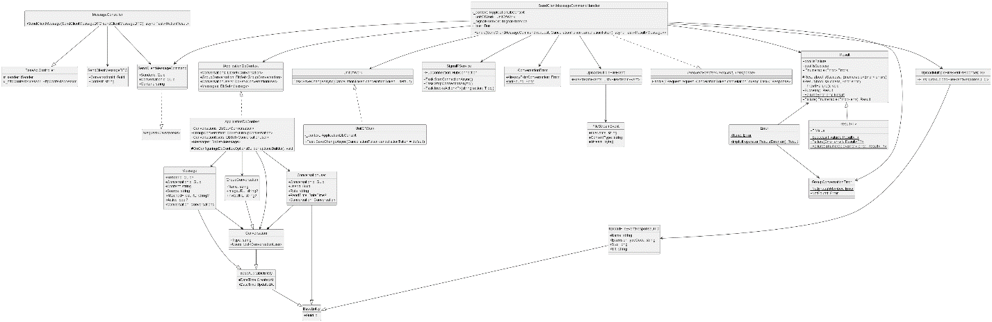

* + 1. **Update Group Conversation**

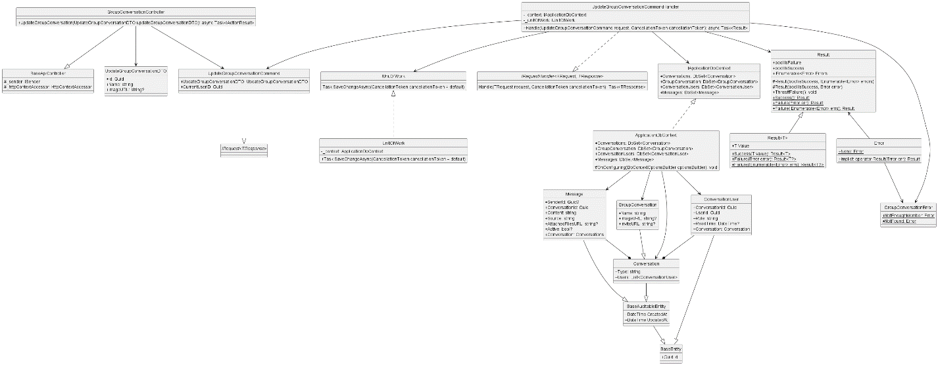

* + 1. **User Exit Group**

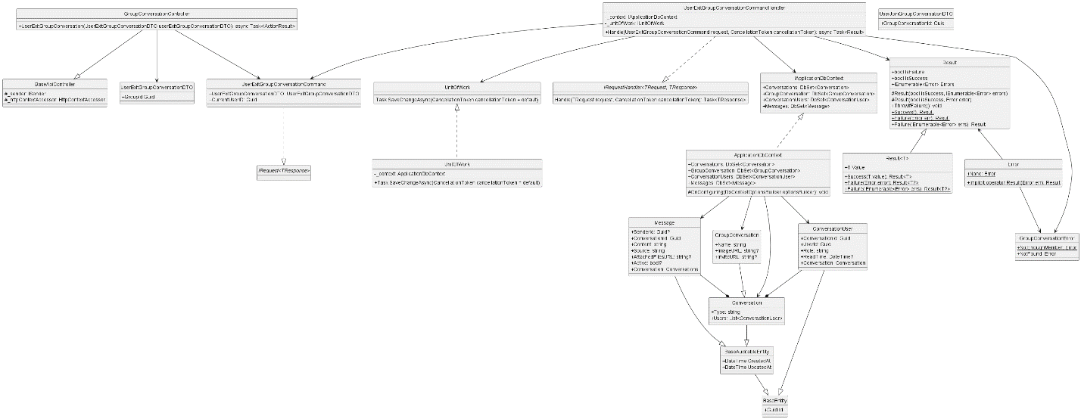

* + 1. **User Join Group**

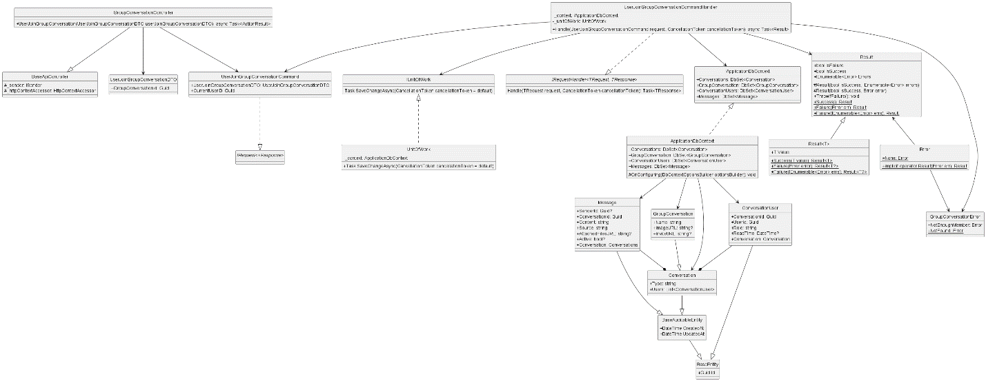

* 1. **Post**
     1. **Create Post**

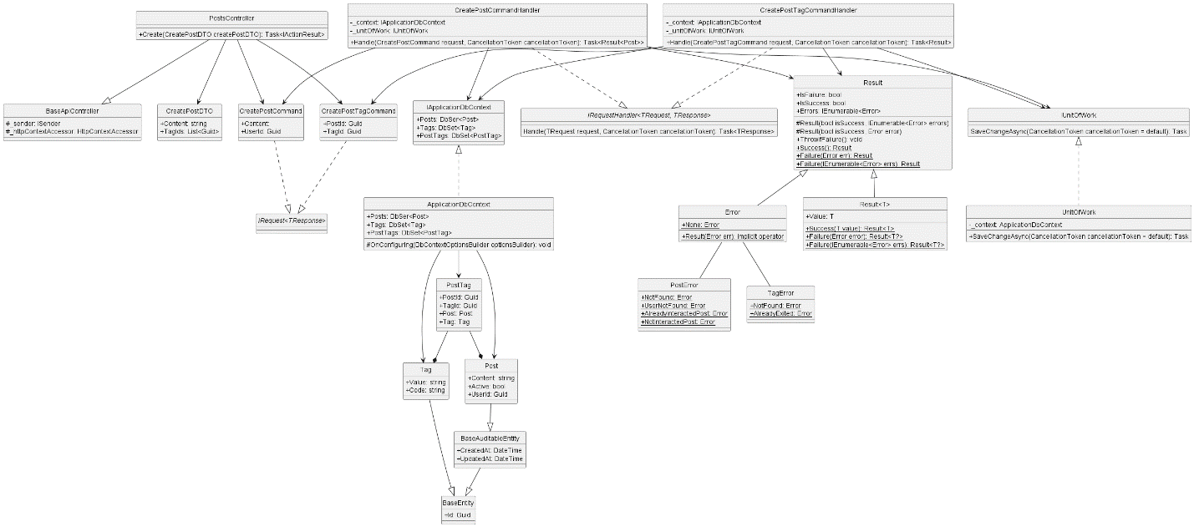

* + 1. **Create Post Interaction**

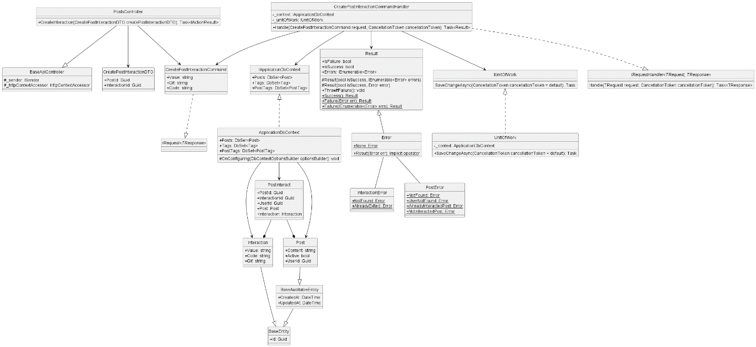

* + 1. **Create Report Post**

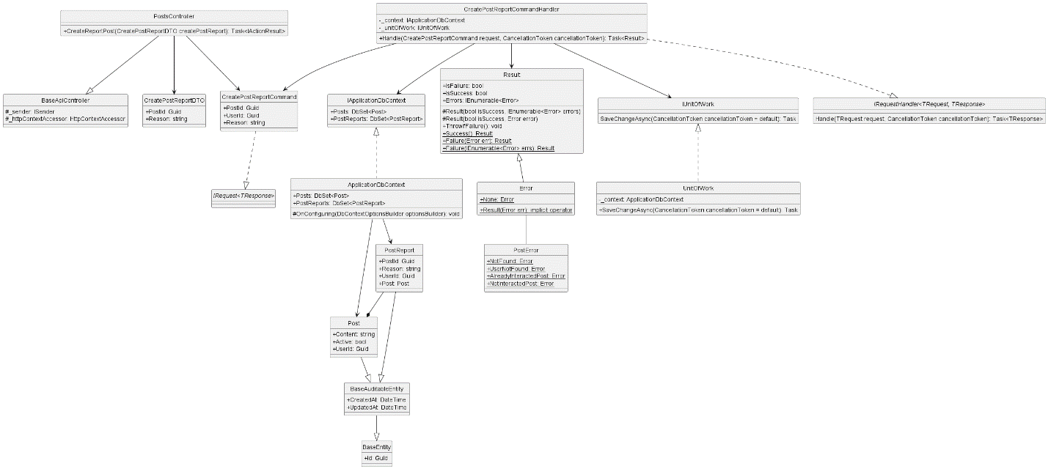

* + 1. **Get All Post**

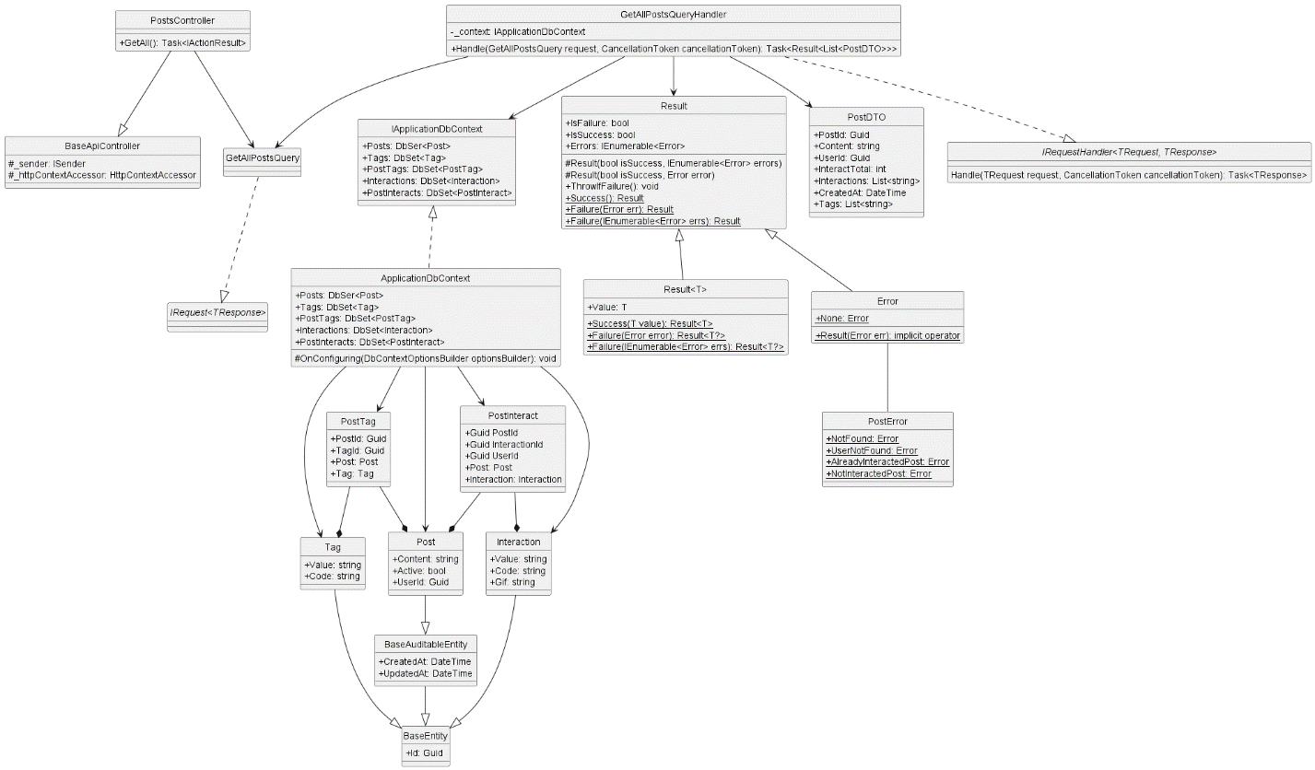

* + 1. **Get All Report Post**

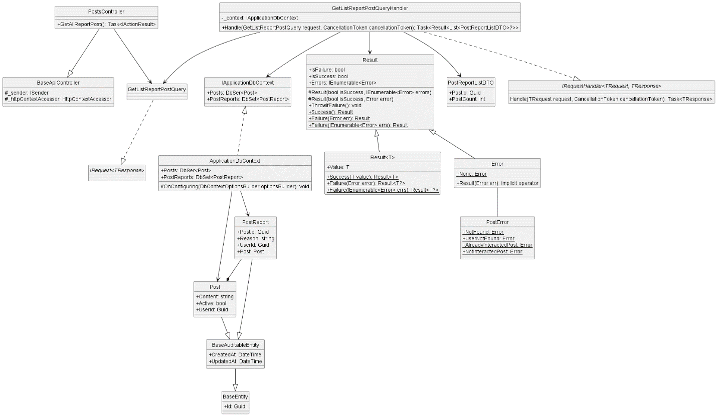

* + 1. **Get Post By Id**

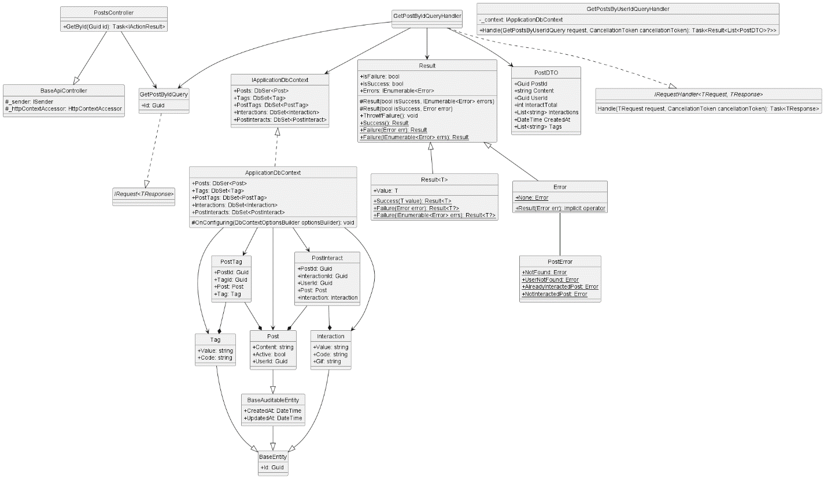

* + 1. **Get By User Id**

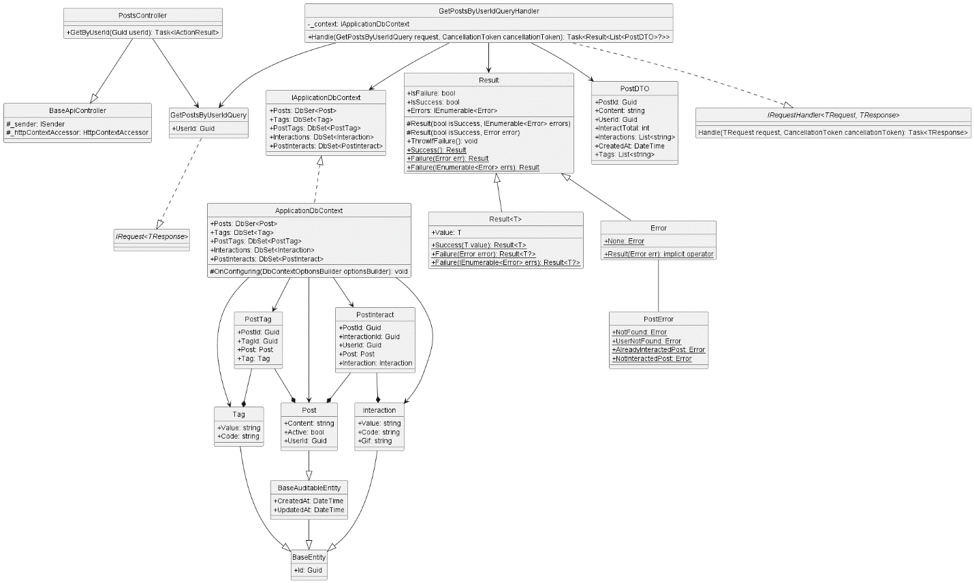

* + 1. **Get Post Interaction**

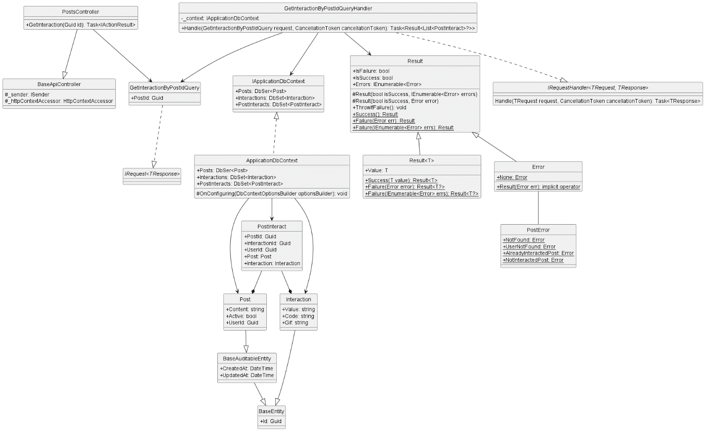

* + 1. **Get Report Post By Post Id**

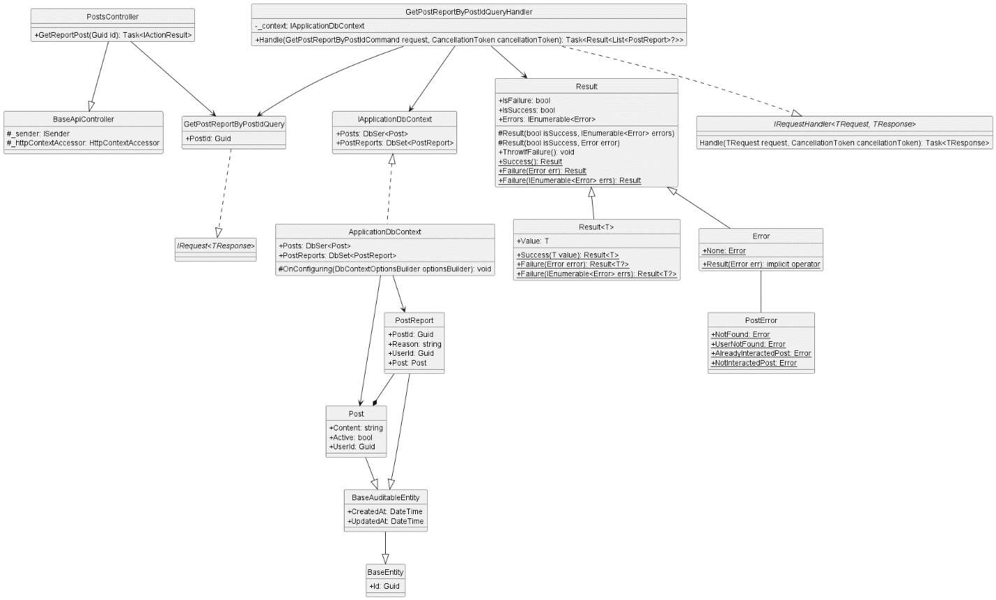

* + 1. **Uninteraction Post**

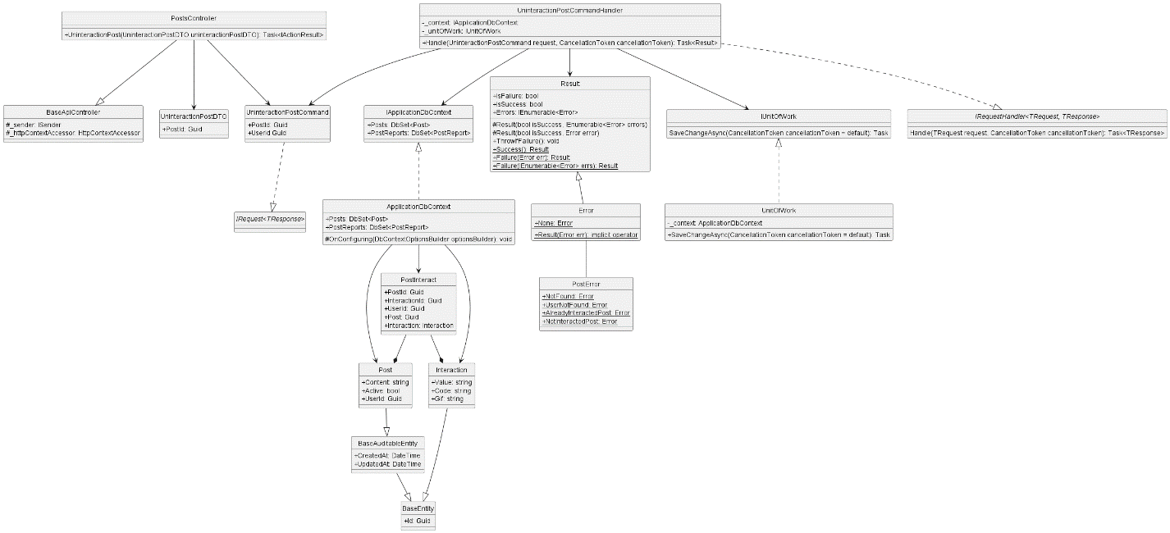

* + 1. **Update Post**

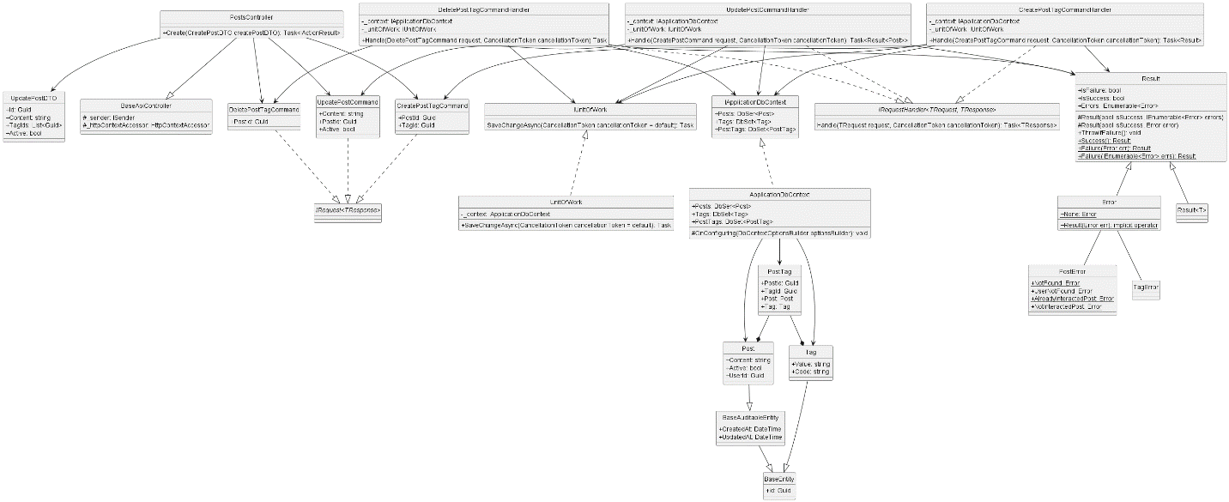

* + 1. **Create Comment**

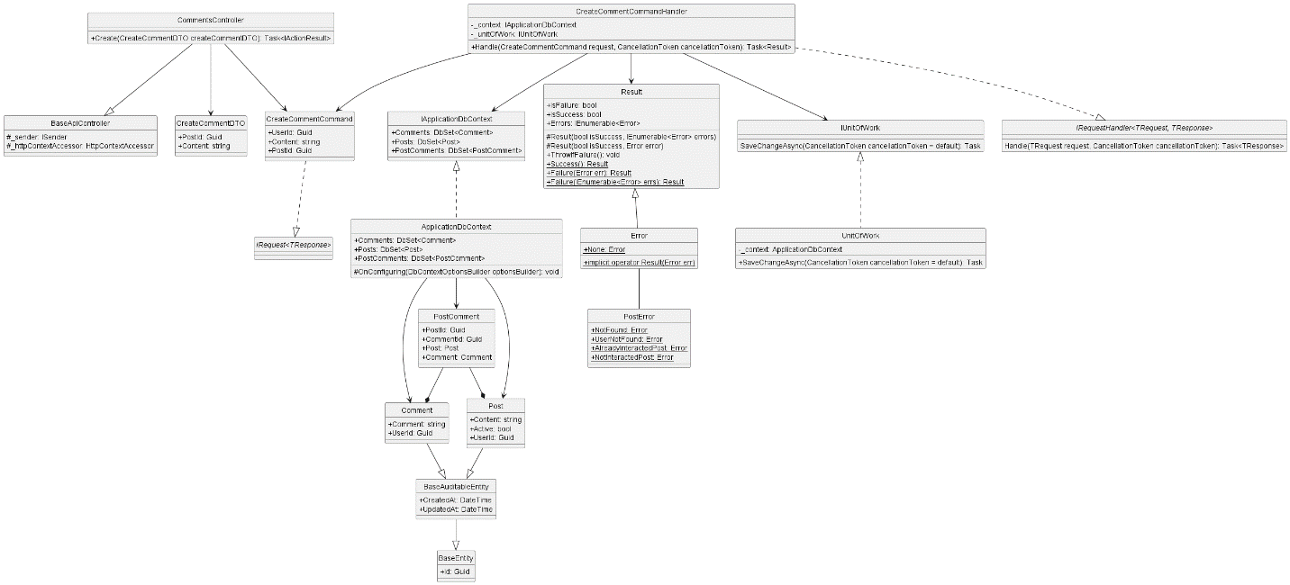

* + 1. **Get Comment By Post Id**

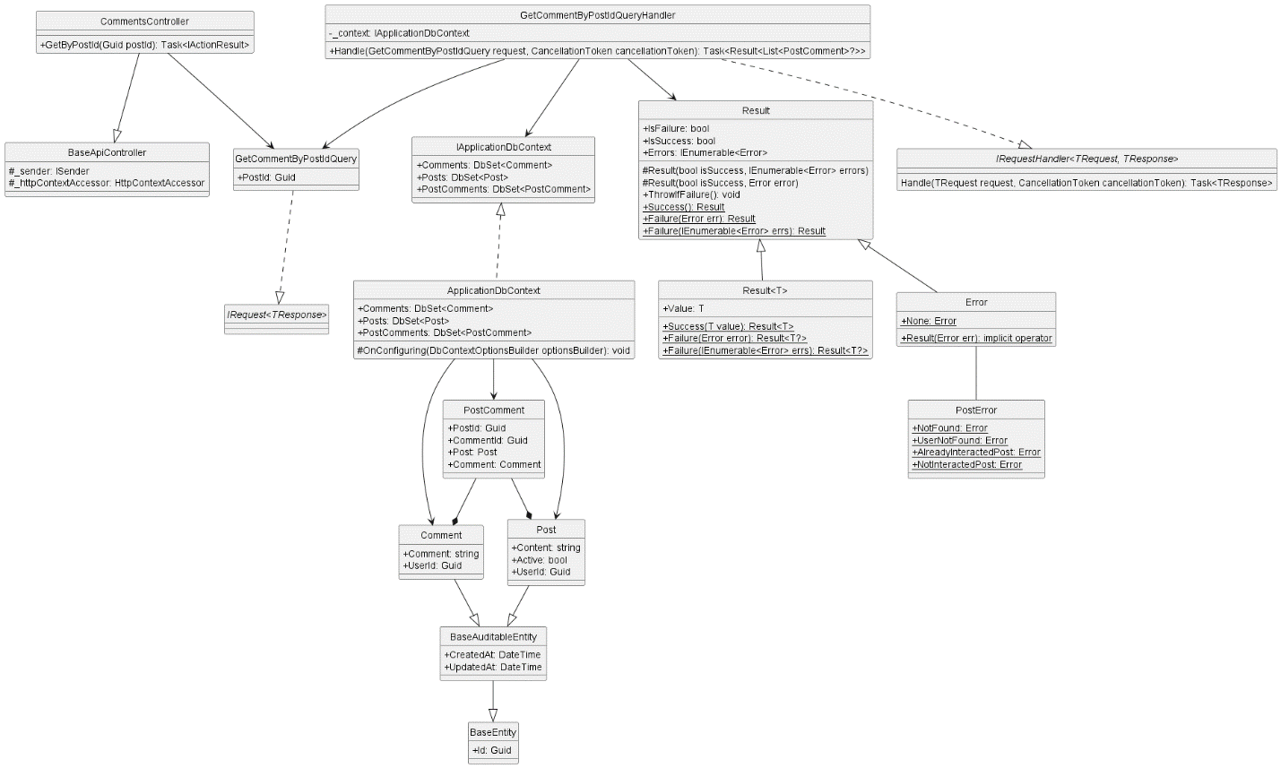

* + 1. **Update Comment**

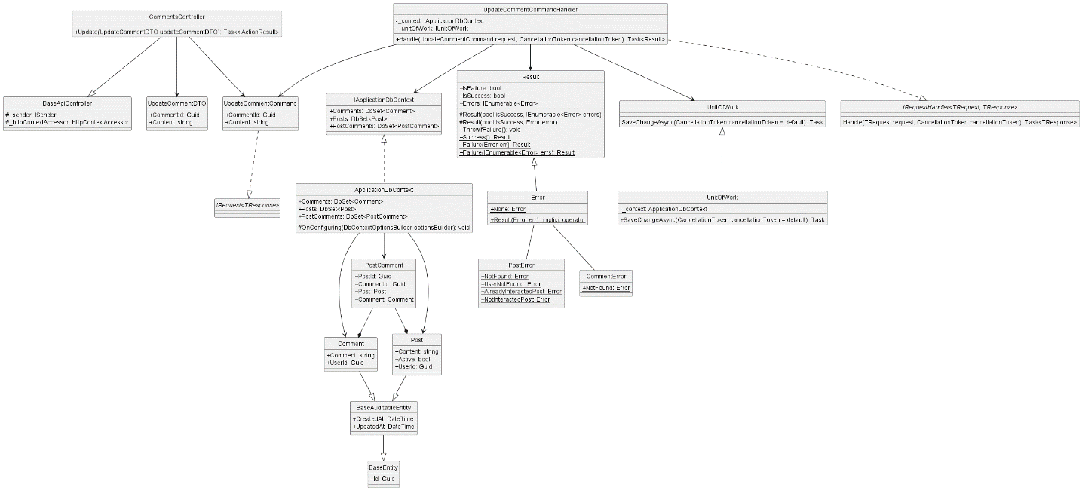

* + 1. **Create Interaction**

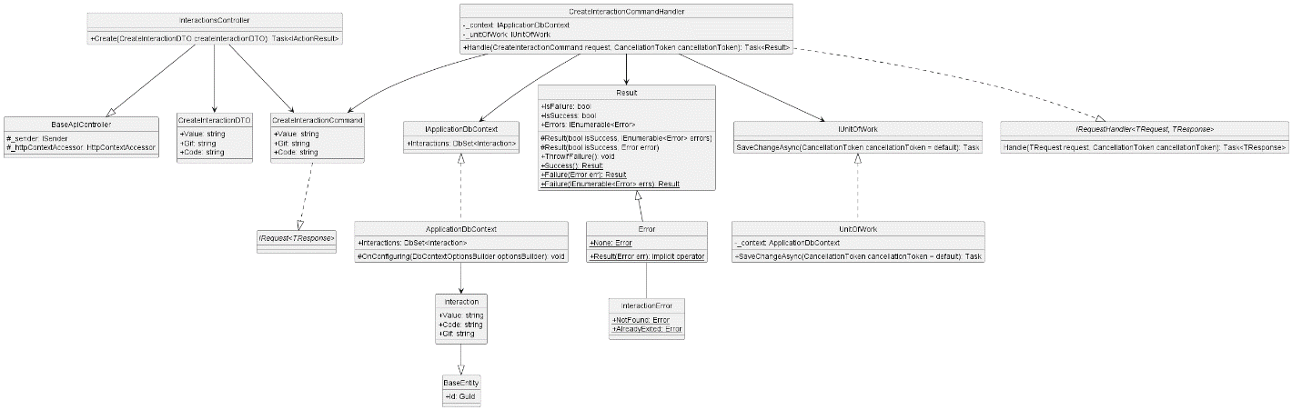

* + 1. **Delete Interaction**

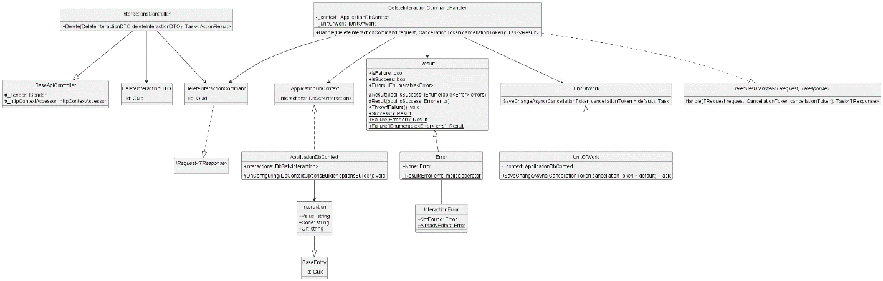

* + 1. **Get All Interaction**

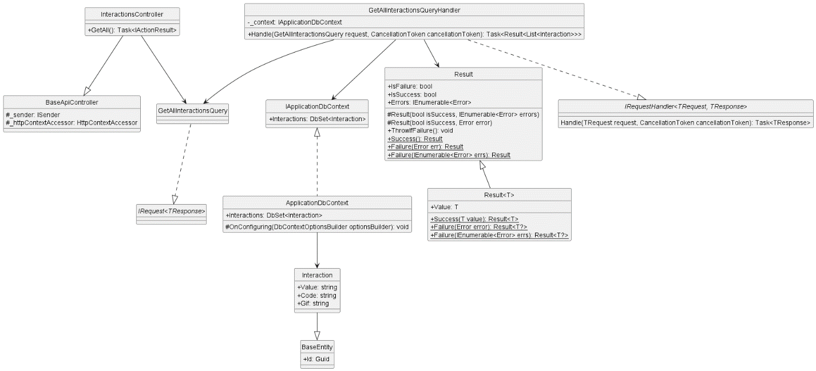

* + 1. **Update Interaction**

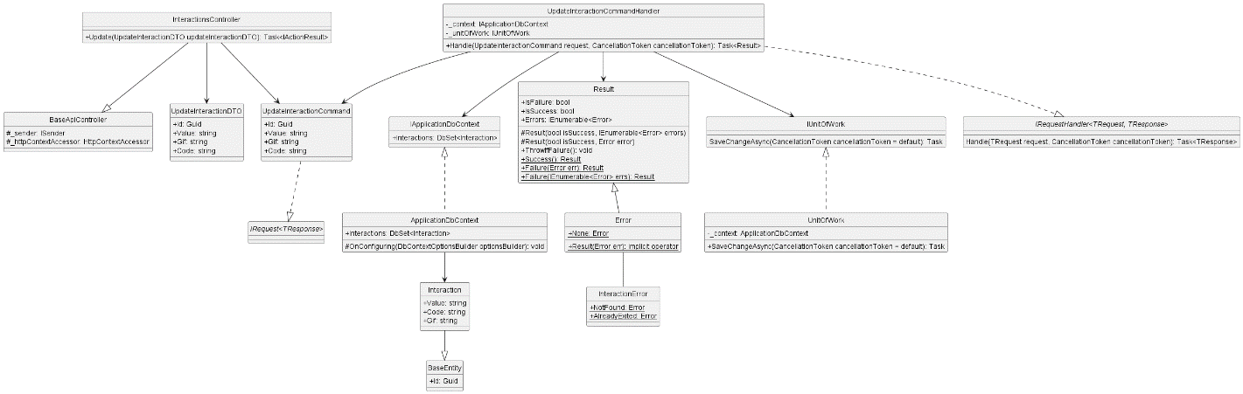

* + 1. **Create Tag**

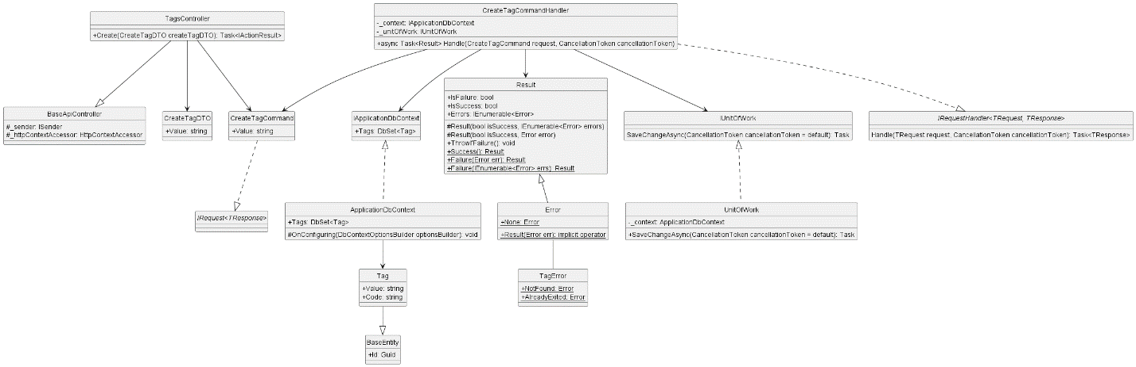

* + 1. **Delete Tag**

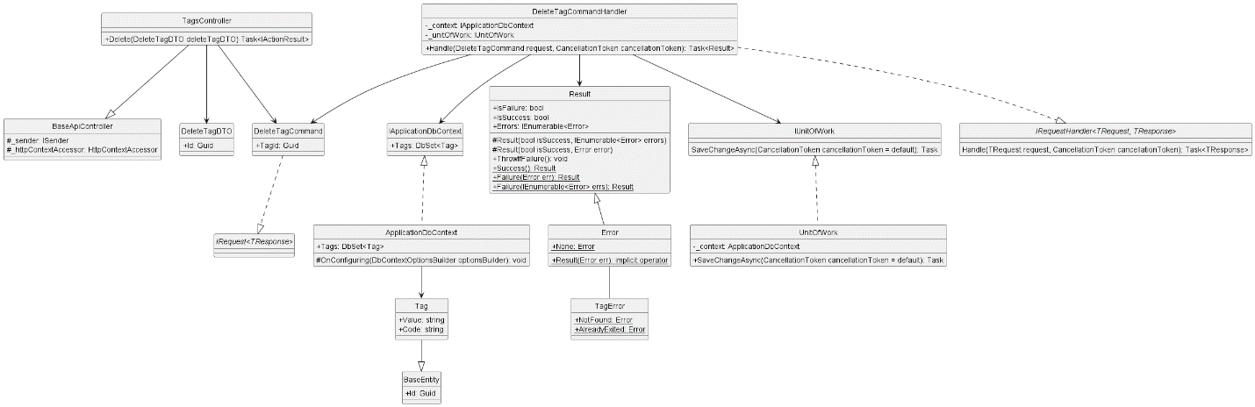

* + 1. **Get All Tag**

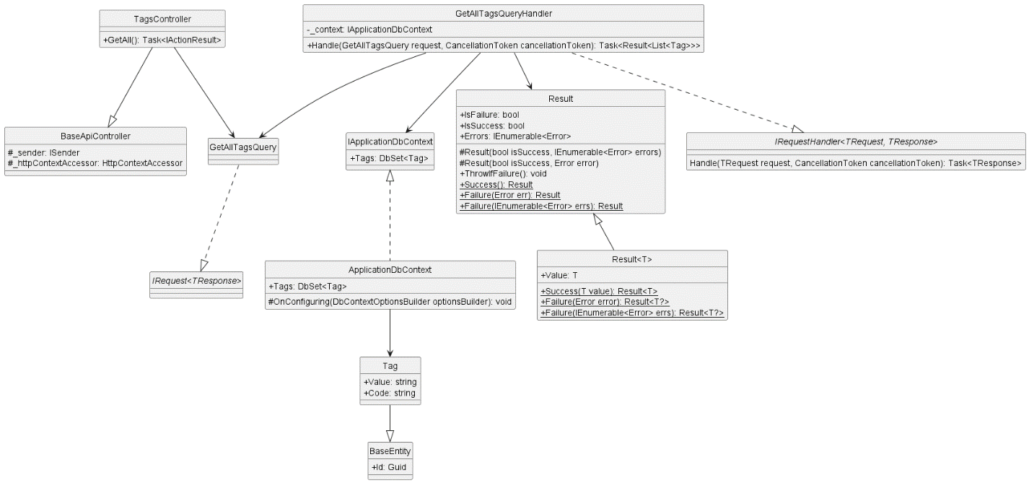

* + 1. **Update Tag**

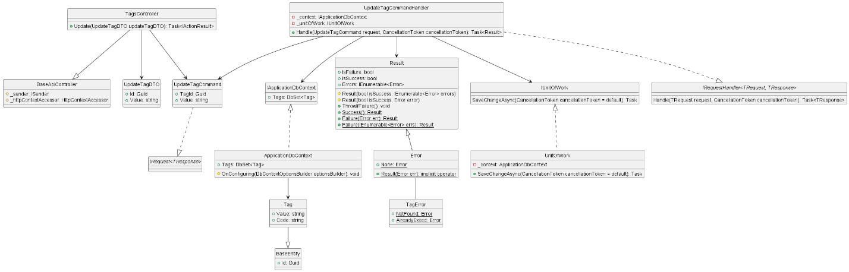

1. **Database diagram**
   1. **File Db**

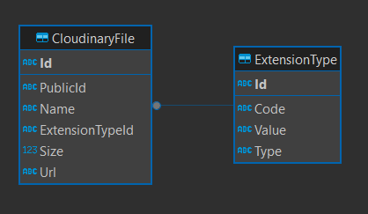

* 1. **IdentityDB**

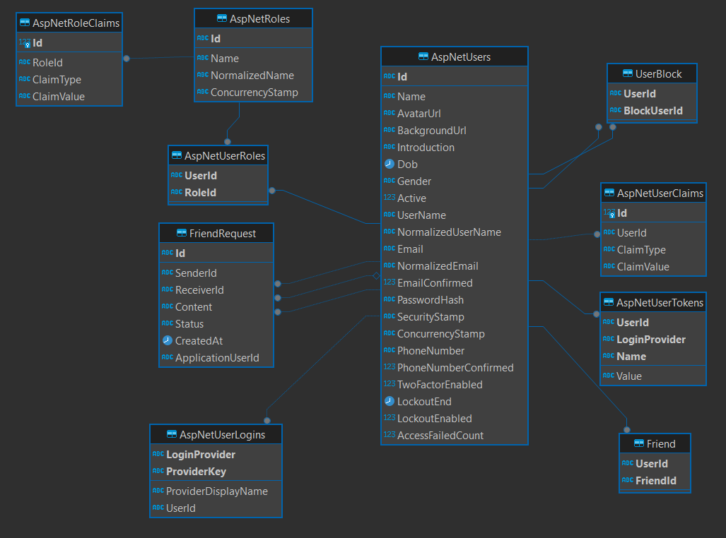

* 1. **MessageDB**

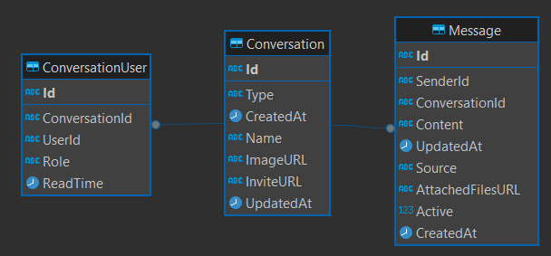

* 1. **PostDB**

